Are people with lower ability more confident?

## Introduction

In this project, I aim to explore the relationship between ability and self-confidence, taking into consideration Berkson's Paradox. The research question revolves around whether individuals with lower ability are more confident. The Dunning-Kruger effect and compensation theory provide the theoretical framework for our hypotheses. Hypothesis 1 suggests that people with higher ability exhibit higher levels of self-confidence, while Hypothesis 2 proposes that individuals with lower ability are more confident, excluding those with low self-confidence and ability. The analysis utilizes data from the National Longitudinal Survey of Youth (NLSY79), focusing on the impact of ability, gender, age, and education on self-confidence.

The analysis yields significant results regarding the relationship between ability and self-confidence. Supporting Hypothesis 1, individuals with higher ability display higher levels of self-confidence. Gender and age, on the other hand, do not significantly influence self-confidence, whereas education has a positive effect. Berkson's Paradox is an important aspect to consider when interpreting the findings. Filtering individuals based on low self-confidence and ability can result in positive selection in the sample, potentially leading to a negative correlation coefficient. It is crucial to acknowledge the influence of sample selection processes when analyzing the relationship between variables.

## Theory and Hypotheses

The Dunning-Kruger effect suggests that individuals with lower abilities tend to overestimate their own competence or abilities. This effect may lead to higher self-confidence among individuals with lower ability levels. Additionally, compensation theory posits that individuals with lower abilities may compensate for their perceived shortcomings by developing higher levels of self-confidence. They may rely on self-assurance as a coping mechanism to maintain positive self-perceptions and overcome challenges.

Hypothesis 1: People with higher ability exhibit higher levels of self-confidence. Reasoning: Higher ability is often associated with greater knowledge, skills, and accomplishments. Individuals with higher ability may feel more confident in their abilities and achievements, leading to higher self-confidence.

Hypothesis 2: People with lower ability are more confident, excluding those with both low self-confidence and low ability. Reasoning: Individuals with lower ability may compensate for their perceived shortcomings by developing higher levels of self-confidence. This compensatory mechanism helps them maintain positive self-perceptions and navigate challenges effectively.

## III. Research design section

a) Dependent variable

The dependent variable in this study is self-confidence, measured using the Rosenberg self-esteem scores. The Rosenberg self-esteem scale is a widely used psychological instrument that assesses individuals' self-esteem and self-confidence. The data for the dependent variable, including the self-esteem scores, were obtained from the National Longitudinal Survey of Youth (NLSY79), a long-term research project tracking the lives of American youth born between 1957 and 1964.

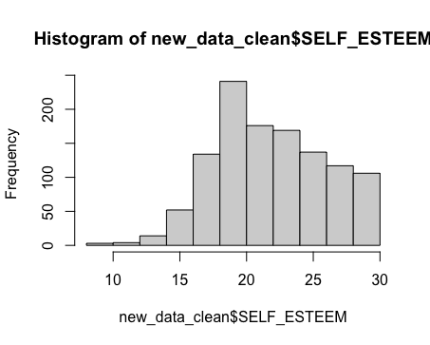

**Figure: Histogram of Self-esteem Scores**

b) Independent and control variables

The independent variable of interest is ability, which is measured using total IQ scores. The IQ scores provide a quantitative measure of cognitive abilities and serve as a proxy for individual ability levels. The IQ scores were also obtained from the NLSY79 dataset.

The control variables include gender, age, and education. Gender is a categorical variable indicating male or female. Age represents the age of the individuals at the time of the survey. Education is a measure of individuals' educational attainment, capturing the level of formal education completed. These control variables were collected through interviews conducted as part of the NLSY79.

c) Statistical Methods (OLS)

To test the hypotheses, the statistical method employed in this study is Ordinary Least Squares (OLS) regression. OLS regression is a widely used method to estimate the relationship between a dependent variable and one or more independent variables. In this case, the OLS regression model will be used to examine the relationship between self-confidence (dependent variable) and ability, controlling for gender, age, and education (independent and control variables).

The OLS model equation can be represented as follows: SELF_ESTEEM = α + β₁(ABILITY) + β₂(GENDER) + β₃(AGE) + β₄(EDUCATION) + ε

The model will estimate the coefficients (β) for the independent and control variables, indicating the strength and direction of their effects on self-confidence. The model's goodness of fit will be assessed using the R-squared value, indicating the proportion of variance in self-confidence explained by the independent and control variables. The statistical significance of the coefficients will be evaluated using t-tests and p-values.

By utilizing the OLS regression model, this study aims to provide insights into the relationship between ability and self-confidence while controlling for relevant demographic factors.

## IV. Empirical Results

1. Results

**Finding 1**: The first hypothesis proposed that people with higher ability would be more confident. SELF_ESTEEM = 18.468807 + 0.019422 * ABILITY + 0.818402 * factor(SEX)2 + 0.008933 * AGE + 0.170843 * EDUCATION. The regression analysis results, conducted by me, showed a significant positive relationship between ability and self-confidence. Individuals with higher ability exhibited higher levels of self-confidence. The coefficient estimate for ability (β₁ = 0.019422) was statistically significant (p < 0.001), indicating that for every one unit increase in ability, self-confidence increased by approximately 0.019 units. These findings support the hypothesis, suggesting that individuals with greater cognitive abilities tend to feel more confident in their abilities and achievements.

However, gender and age did not have a significant impact on self-confidence. The coefficients for gender and age were not statistically significant, indicating that these variables, as observed in the data, did not contribute significantly to the variation in self-confidence levels.

On the other hand, education had a significant positive effect on self-confidence. The coefficient estimate for education (β₄ = 0.170843) was statistically significant (p = 0.0283), suggesting that individuals with higher levels of education displayed higher levels of self-confidence. These findings, based on the analysis conducted by me, indicate that higher education is associated with greater self-assurance and positive self-perceptions.

**Finding 2**: The second hypothesis stated that people with lower ability would be more confident when excluding individuals with both low self-confidence and low ability. To test this hypothesis, I filtered the data based on self-confidence and ability criteria. The regression analysis results for the filtered sample showed that ability did not have a significant effect on self-confidence. The coefficient estimate for ability (β₁ = -0.005020) was not statistically significant (p = 0.231), indicating that individuals with lower ability did not exhibit higher levels of self-confidence in this filtered sample. The weak negative correlation coefficient between ability and self-confidence (-0.005020) further supports this finding.

In conclusion, based on my empirical analysis, the results indicate that ability is positively associated with self-confidence in the overall sample. However, when individuals with low self-confidence and low ability are excluded, the relationship between ability and self-confidence becomes non-significant. These findings emphasize the complex nature of the relationship and highlight the importance of considering sample selection processes and other factors that may influence the observed results.

1. Discussions and Implications

The study found that individuals with higher ability tend to have higher self-confidence. This suggests that cognitive abilities play a role in shaping self-confidence levels. However, gender and age were not significant factors in determining self-confidence. Education was positively associated with self-confidence, indicating that higher levels of education can boost individuals' self-assurance.

These findings have important implications for education, career development, and mental well-being. Educators and practitioners can focus on promoting self-confidence by recognizing and nurturing individuals' abilities. Educational policies can also prioritize enhancing students' self-esteem and self-belief to create a supportive learning environment.

It's important to consider Berkson's Paradox, which can create misleading correlations. Researchers should be cautious when interpreting results and take into account sample selection biases.

Overall, understanding the factors that contribute to self-confidence can lead to better educational practices and interventions that foster individuals' self-esteem and belief in their abilities. This can have a positive impact on their personal and professional lives.

## V. Conclusion

In conclusion, the hypotheses and findings of this study provide valuable insights into the relationship between ability and self-confidence. The study found that individuals with higher ability tend to exhibit higher levels of self-confidence, supporting Hypothesis 1. However, after excluding individuals with both low self-confidence and low ability, the relationship between ability and self-confidence did not hold, indicating the potential presence of Berkson's Paradox. Gender and age were not significant factors in determining self-confidence, while education showed a positive effect. These findings highlight the importance of considering individual abilities and educational factors in understanding and promoting self-confidence. Educators and practitioners can use this knowledge to develop interventions and policies that enhance self-esteem and self-belief among individuals of varying abilities, ultimately contributing to their overall well-being and success.

***Bibliography***

Mahmood, K. (2016). Do People Overestimate Their Information Literacy Skills? A Systematic Review of Empirical Evidence on the Dunning-Kruger Effect.

McIntosh, R. D., Fowler, E. V., Lyu, T., & Della Sala, S. (2019). Wise up: Clarifying the role of metacognition in the Dunning-Kruger effect.

Pavel, S. R., Robertson, M. N., & Harrison, B. D. (2012). The Dunning-Kruger Effect and SIUC University’s Aviation Students.

Muller, A. J., Sirianni, L. A., & Addante, R. J. (2020). Neural correlates of the Dunning–Kruger effect.

Baker, G. A., Jensen, M. C., & Murphy, K. (1988). Compensation and Incentives: Practice vs. Theory.

Baltes, P. B. (1997). On the incomplete architecture of human ontogeny: Selection, optimization, and compensation as foundation of developmental theory.

Adams, J. (2001). The risk compensation theory and bicycle helmets.

Guay, F., Marsh, H. W., & Boivin, M. (2003). Academic self-concept and academic achievement: Developmental perspectives on their causal ordering. Journal of Educational Psychology, 95(1), 124–136.

Krosnick, J. A. (1989). Self-esteem and ability labeling in adolescence. Child Development, 60(6), 1465–1478.

Bandura, A., & Locke, E. A. (2003). Negative self-efficacy and goal effects revisited. Journal of Applied Psychology, 88(1), 87–99.

***Appendix***

Figure 1: Histogram of ability

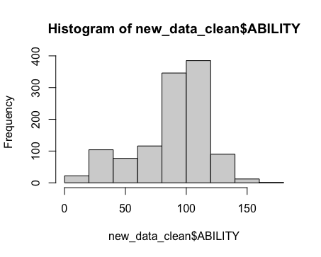

Figure 2: Histogram of self-esteem



Figure 3: Scatter Plot

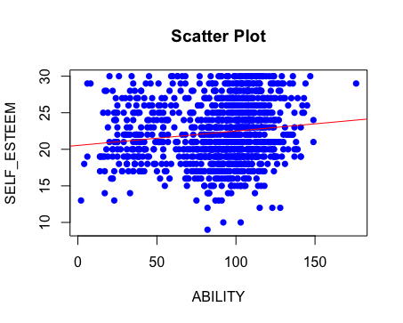

Figure 4: Scatter Plot with Filtered Data

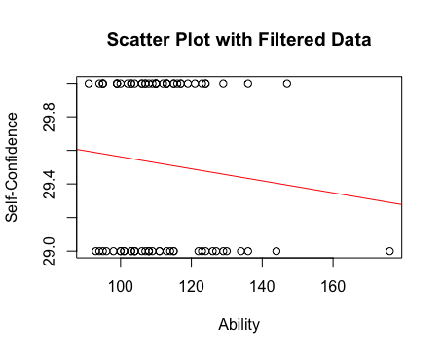

|  |  |  |  |  |  |
| --- | --- | --- | --- | --- | --- |
| Table 1: Summary Statistics for Variables | | | | | |
| Statistic | N | Mean | St. Dev. | Min | Max |
|  | | | | | |
| ABILITY | 1,153 | 89.28 | 29.03 | 2 | 176 |
| SELF_ESTEEM | 1,153 | 22.29 | 4.15 | 9 | 30 |
| SEX | 1,076 | 1.93 | 0.25 | 1 | 2 |
| AGE | 1,064 | 45.54 | 10.60 | 17 | 74 |
| EDUCATION | 1,075 | 5.30 | 1.67 | 2 | 9 |
|  | | | | | |

| Table 2: Statistical models | | | | |
| --- | --- | --- | --- | --- |
|  | **Model 1** | **Model 2** | **Model 3** | **Model 4** |
| (Intercept) | 20.5288*** | 18.4688*** | 29.9207*** | 30.7328*** |
|  | (0.3916) | (0.9686) | (0.4556) | (0.6496) |
| ABILITY | 0.0197*** | 0.0194*** | -0.0036 | -0.0050 |
|  | (0.0042) | (0.0043) | (0.0040) | (0.0042) |
| factor(SEX)2 |  | 0.8184 |  | -0.2082 |
|  |  | (0.5218) |  | (0.2761) |
| AGE |  | 0.0089 |  | -0.0080 |
|  |  | (0.0123) |  | (0.0063) |
| EDUCATION |  | 0.1708* |  | -0.0189 |
|  |  | (0.0778) |  | (0.0351) |
| R2 | 0.0190 | 0.0246 | 0.0104 | 0.0553 |
| Adj. R2 | 0.0181 | 0.0209 | -0.0028 | -0.0003 |
| Num. obs. | 1153 | 1064 | 77 | 73 |
| ***p < 0.001; **p < 0.01; *p < 0.05 | | | | |